DATA PRE-PROCESSING:
Converted Raw data into Tables
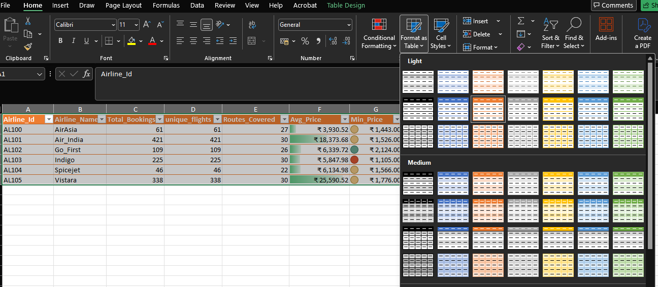
- AIRLINES
- Checked the Airlines table for duplicate values.
- Checked and handled missing values.
- Standardized the airline-related data.
- Created calculations for Total Bookings, Routes Covered, Average Price, Minimum Price and Maximum Price.
- Calculated Economy and Business class bookings.
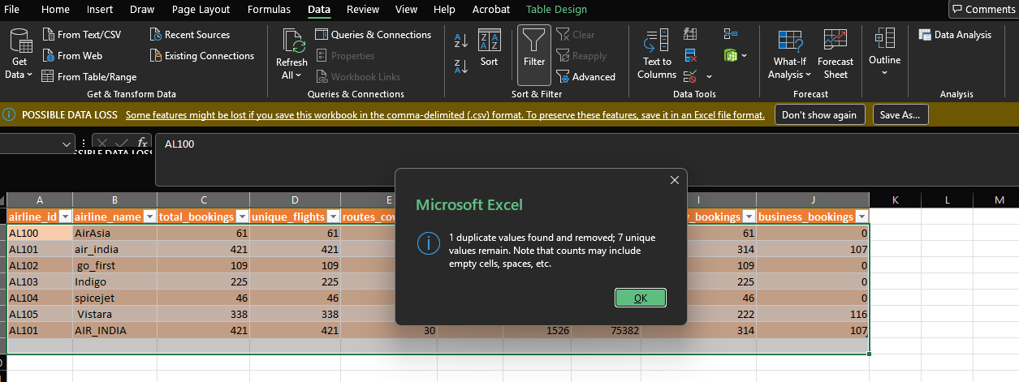
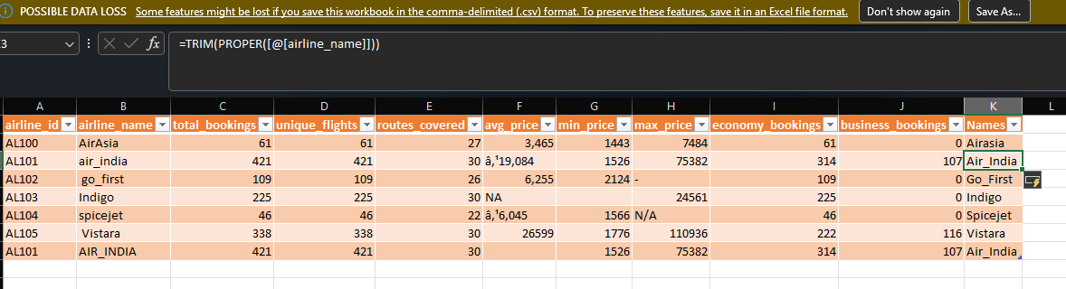
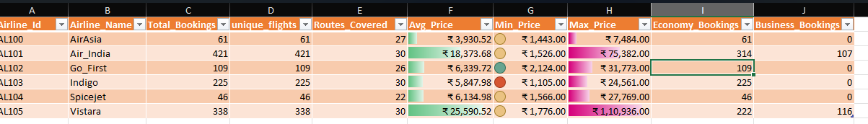
- BOOKINGS
- Checked the Bookings table for duplicate values.
- Checked and handled missing values.
- Corrected the data types of the required columns.
- Used lookup functions to retrieve the required airline and flight information.
- Created a new Booking Window column using Days Left.
- Categorized bookings into Last Minute, Short Notice, Moderate and Advance.
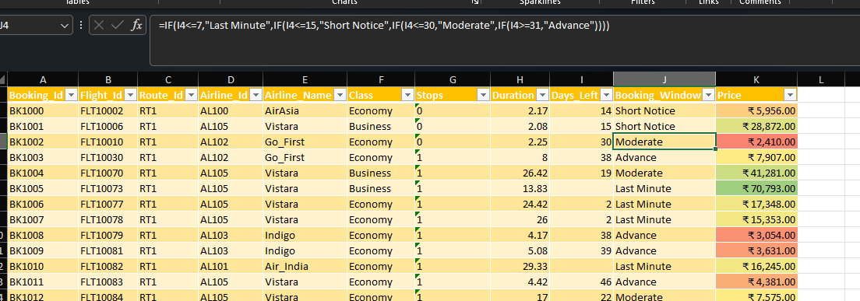
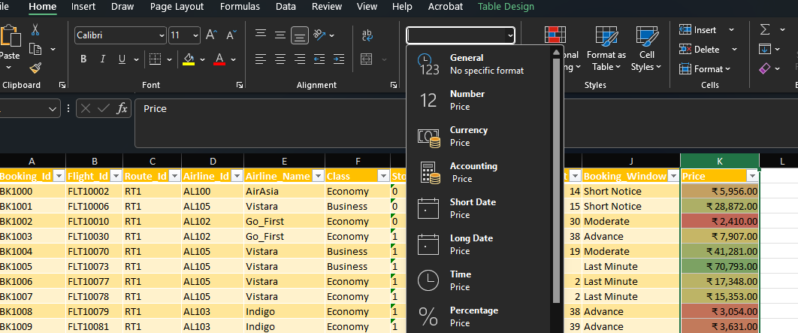
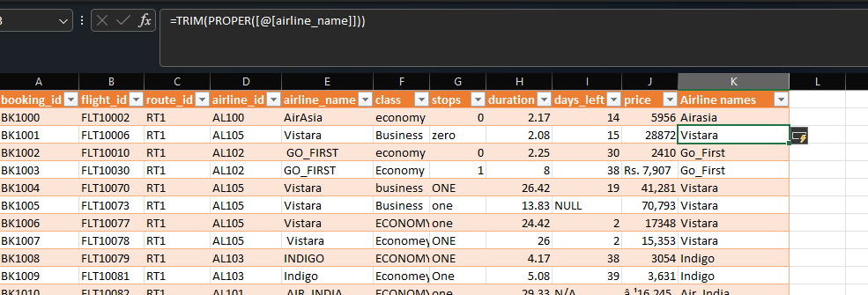
- FLIGHTS
- Checked the Flights table for duplicate values.
- Checked and handled missing values.
- Corrected data types of the required columns.
- Standardized Source City and Destination City values.
- Created a new Route column by combining Source City and Destination City.
- Checked and standardized flight-related information.
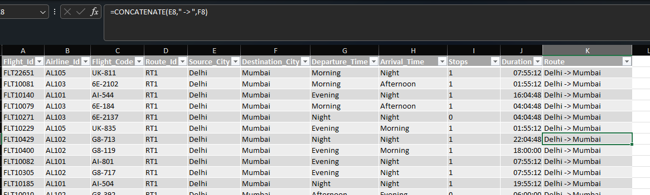
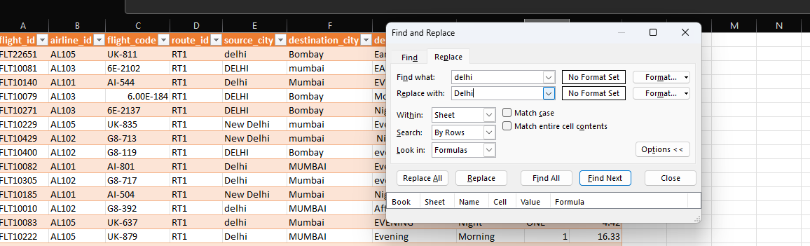

- ROUTES
- Checked the Routes table for duplicate values.
- Checked and handled missing values.
- Calculated Total Bookings for each route.
- Calculated Unique Flights and Airlines Serving each route.
- Calculated Average Price, Minimum Price and Maximum Price.
- Calculated Average Duration.
- Calculated Economy and Business bookings.
- Used COUNTIF, COUNTIFS, AVERAGEIF, AVERAGEIFS, MINIFS and MAXIFS functions.
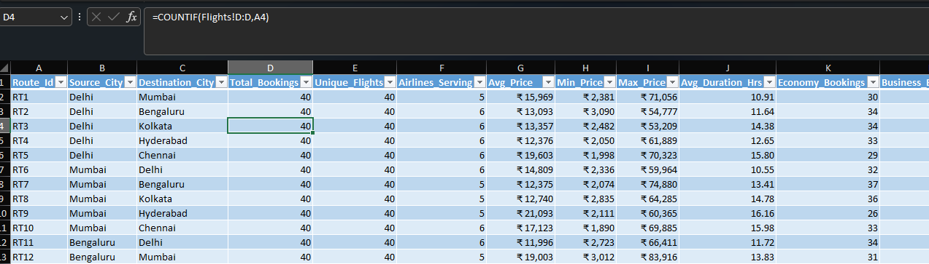
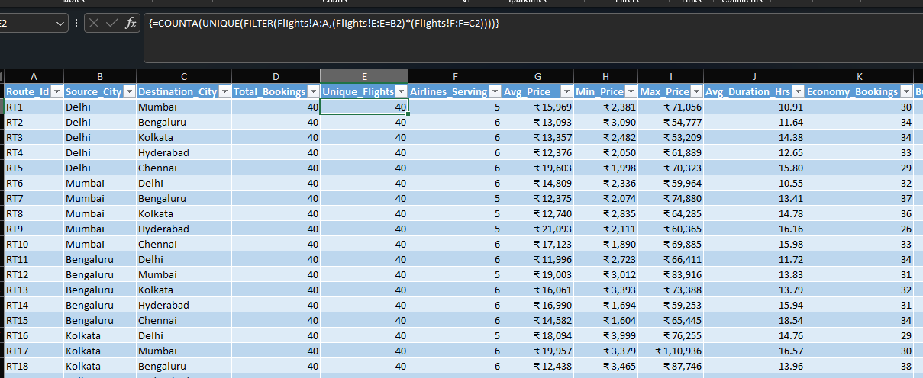
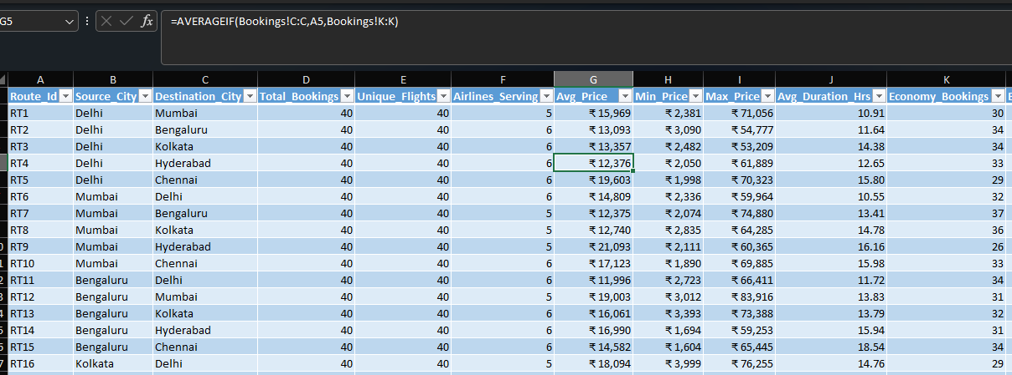
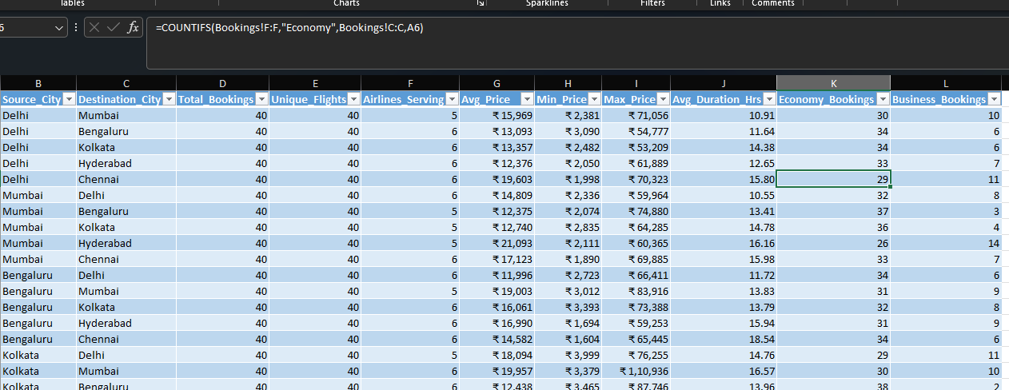
- ANALYSIS
- Combined information from different tables using lookup functions.
- Used VLOOKUP and XLOOKUP to retrieve required information.
- Created a Route column using Source City and Destination City.
- Created Booking Window based on Days Left.
- Created Duration Category based on flight duration.
- Created Price Category based on ticket price.
- Prepared the final dataset for analysis.
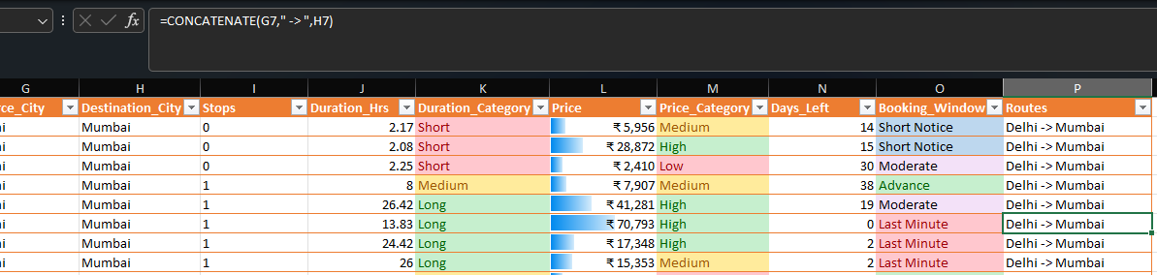
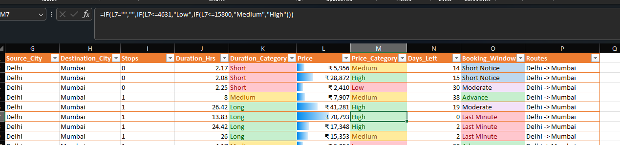
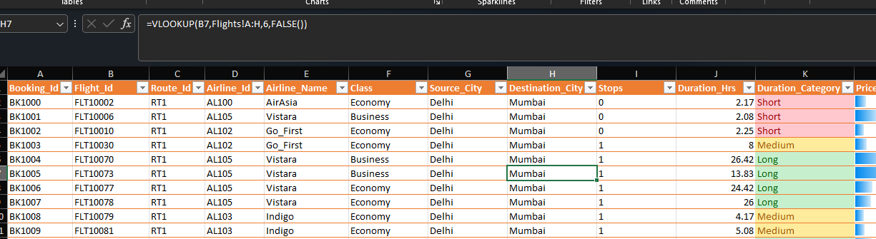
- PIVOT TABLE:
- Created PivotTables to summarize the cleaned data.
- Performed airline-wise booking analysis.
- Performed class-wise booking analysis.
- Analyzed average, minimum and maximum ticket prices.
- Compared booking and pricing information across airlines.
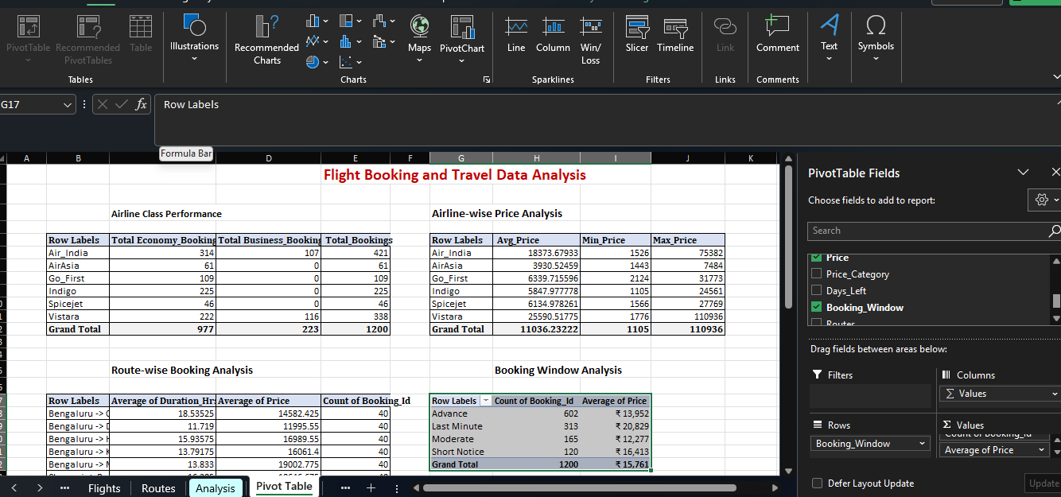
- DESCRIPTIVE STATISTICS:
- Calculated descriptive statistics for the required numerical variables.
- Calculated Mean, Median, Mode
- Calculated Standard Deviation, Variance, Range.
- Calculated Minimum and Maximum.
- Calculated Sum and Count.
- Calculated Skewness and Kurtosis, Standard Error.
- 